Phone 0141-287 4551
Fax 0141-287 4895
Our Ref MMcK/SLA/ Your Ref
Date 22 April 2013
If phoning please ask for Maureen McKenna
email maureen.mckenna@education.glasgow.gov.uk

Dear Parent/ Carer

CONSULTATION ON IN-SERVICE DAYS
SESSION 2013-14 AND 2014-15

We have consulted and published our calendars for the above two years. However, we have now received word that 22 May 2014 will be the date of the European elections and
18 September 2014 will be the Independence Referendum. As you know, despite our best efforts, there are still a number of nurseries and schools which are used as polling stations.

I would like to seek your views in making changes to the in-service days to make these dates in-service days for staff only to minimise the disruption to children’s learning.

I am proposing to change In-Service Day 5 of session 2013-14 to 22 May 2014 and In-Service Day 3 of session 2014-15 to 18 September 2014, ie

2013-14  In-service Day 5 | Change from:  Thursday 5th June 2014 | Change to:  Thursday 22nd May 2014
2014-15  In-service Day 3 | Change from:  - Thursday 25 September 2014 (NE)  - Tuesday 30 September 2014 (South)  - Monday 20 October 2014 (NW) | Change to:  Thursday 18th September 2014  (all establishments)

I would be grateful if you could return the attached tear-off slip to your nursery or school or record your view using the electronic response form http://www.glasgow.gov.uk/schoolconsultations

All responses should be submitted by Friday 17th May 2013.

Yours sincerely
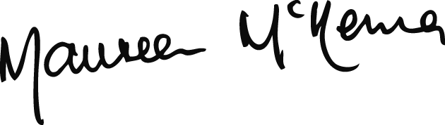
MAUREEN McKENNA
Executive Director of Education

